**Steps to Process a Title via Evergreen CM**

1. On the Ingest tab mention a new identifier and choose the Business Unit/ Sub Business Unit/ Directory and the workflow (Simple ebook or Standard ebook)

**Note:** This identifier, BU/SBU/Directory, and workflow needs to be selected always when you perform any action either on Ingest tab or on Title action screen.

1. Click on Choose files button.
2. It will check either it’s a new identifier or an existing one. In case of a new identifier it will display following message click on yes to create an identifier at the BU/SBU/Directory location.

**Note:** if its existing one it will display the files present in the identifier.

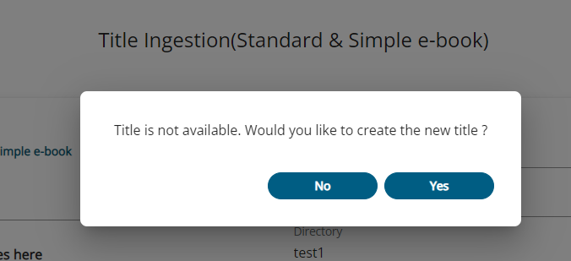

1. Post identifier is created following screen will be displayed on clicking on Choose files.

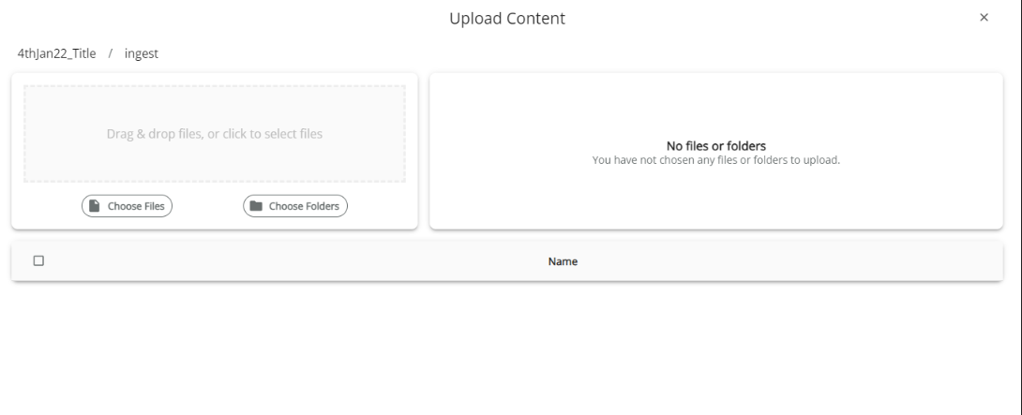

1. Now when the new identifier is created automatically an ingest folder is created and user is asked to upload the Source content of ingest here directly that is the assets and pdf folder.

Once user upload the folder the loader starts loading.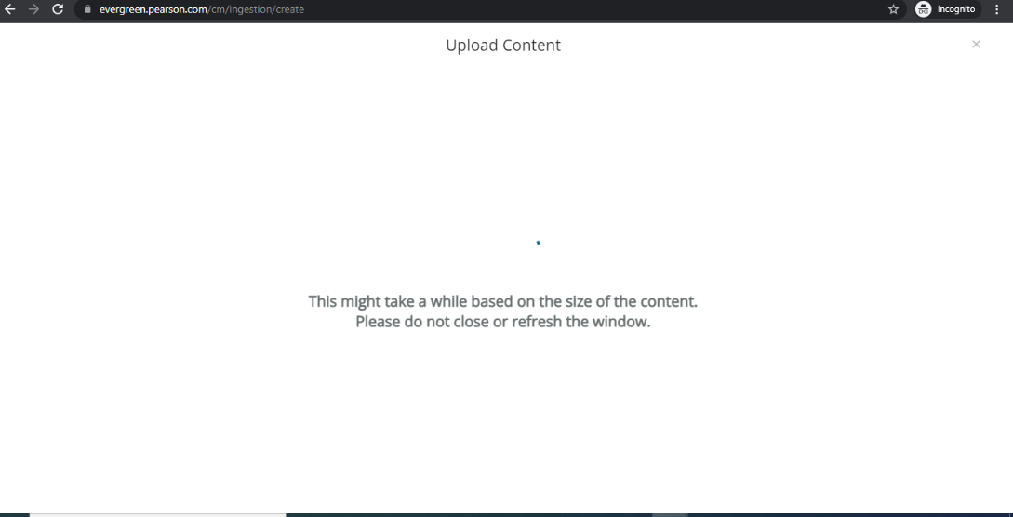

One files are uploaded it displays like following:

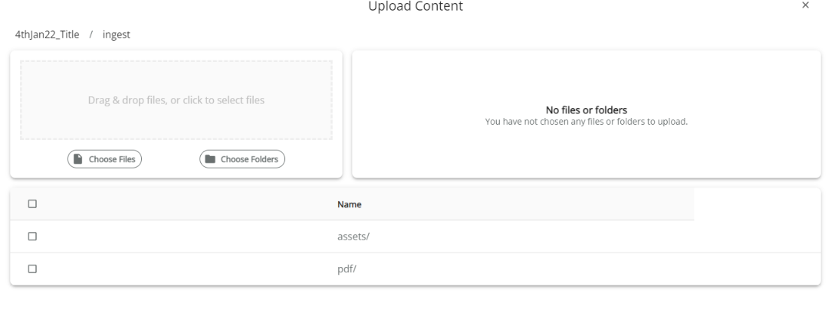

1. Now user can close this window and come back to the ingest screen make sure that the identifier and SBU/BU/Directory is correctly selected Choose all the check boxes and click on create.

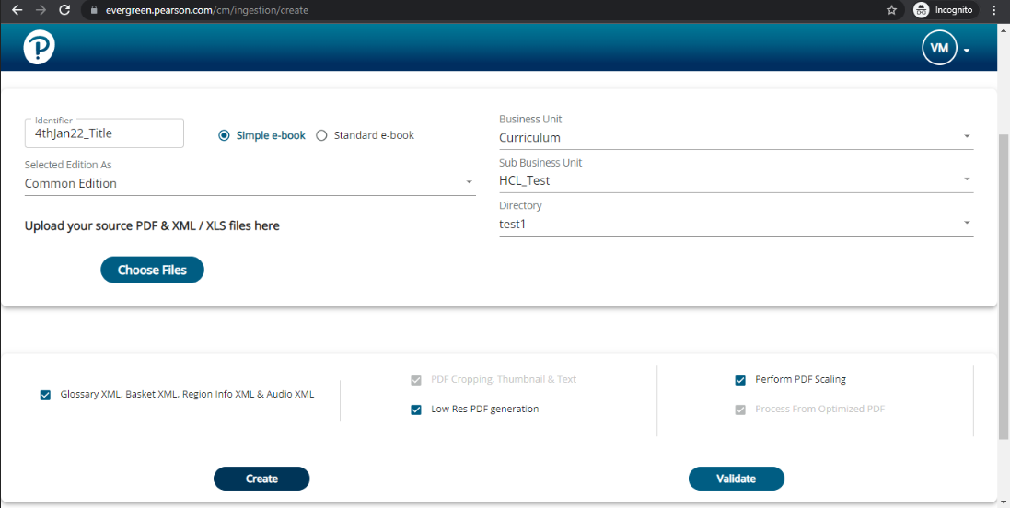

1. Just after clicking on create the ebook transformation will start and all the process will go till EPS ingestion successful.

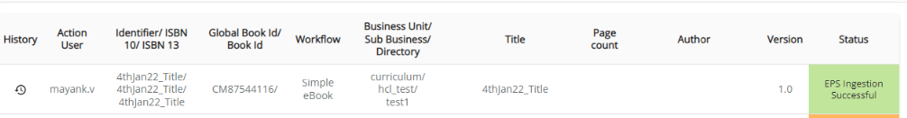

1. One EPS ingestion Successful again come back to the Ingest tab select the identifier BU/SBU /Directory and now validate the title. By clicking on validate button.



1. Once validation done the status would be content validation successful.

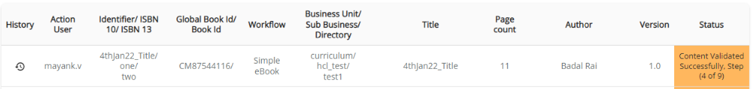

1. Then navigate to Title action screen choose the identifier , BU/SBU/Directory and then click on Upload to Authoring.

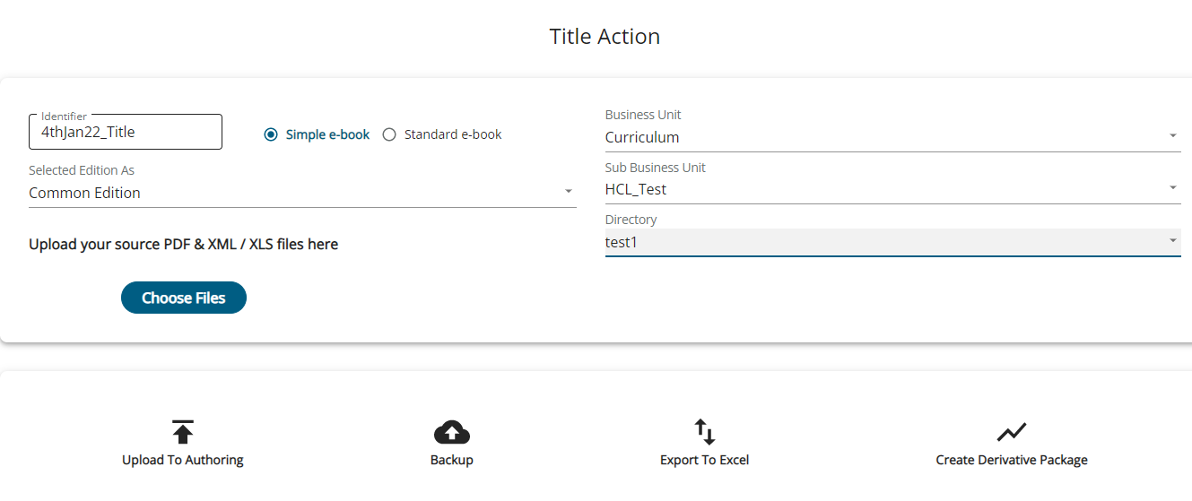

1. Once Authoring ingestion is done successfully then the status will be as follows and this title can now be searched on Evergreen Authoring also with corresponding Book id /GBID.



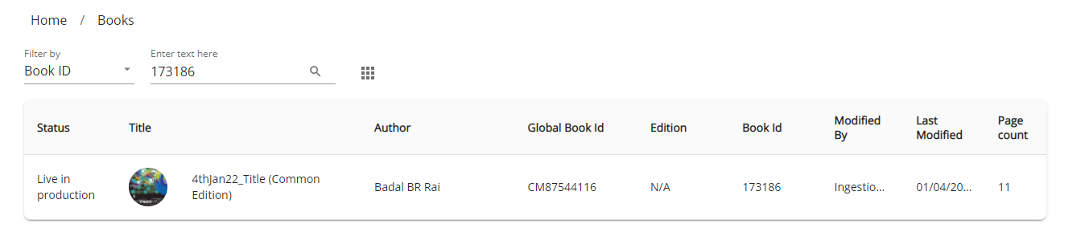

1. Following is the title history that would be followed in processing the whole title.

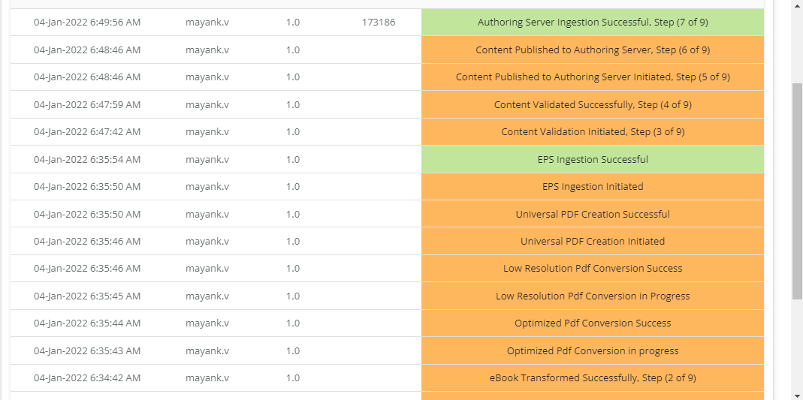

**Steps to Submit Request/Revision Form in eText DB**

**For Request Form**

1. In the Request Form, fill the text fields (Name, Email, PhoneNo. etc) with the data .

**Note:** The mandatory fields must be populated with data otherwise the submit button will not work. The mandatory fields for request form are as follows:-

**Name, Email, Phone No., Publishing Company/Division, Parent ISBN-10, Parent ISBN-13, Title/edition, Author, Copyright Year, eText ISBN-10, eText ISBN-13, Total no. of pages, Compositor, eText Product Type, Type of source file, Discipline code, Cover Artwork, TOC Spreadsheet, Hotspot UI.**

**Note:** The Publishing Company/Division field must select options (Arts&Sciences, Professional & Career, International, PTG, PLS) . And in addition to that dropdown must also be selected with that division option. Otherwise the error will be there in submitting the form.

1. On getting submitted the request id will be displayed in request queue.

**For Revision Form**

1. In the Revision Form, fill the text fields (Name, Email, PhoneNo. etc) with the data .

**Note:** The mandatory fields must be populated with data otherwise the submit button will not work. The mandatory fields for request form are as follows:-

**Name, Email, Phone No., Publishing Company/Division, Parent ISBN-10, Parent ISBN-13, Title/edition, Author, Copyright Year, eText ISBN-10, eText ISBN-13, Book ID, Type of Revision, Folder Name.**

**Note:** The Publishing Company/Division field must select options (Arts&Sciences, Professional & Career, International, PTG, PLS) . And in addition to that dropdown must also be selected with that division option. Otherwise the error will be there in submitting the form.

1. On getting submitted the revision form with new book id that doesn’t exist , a dummy request confirmation will be there as follows—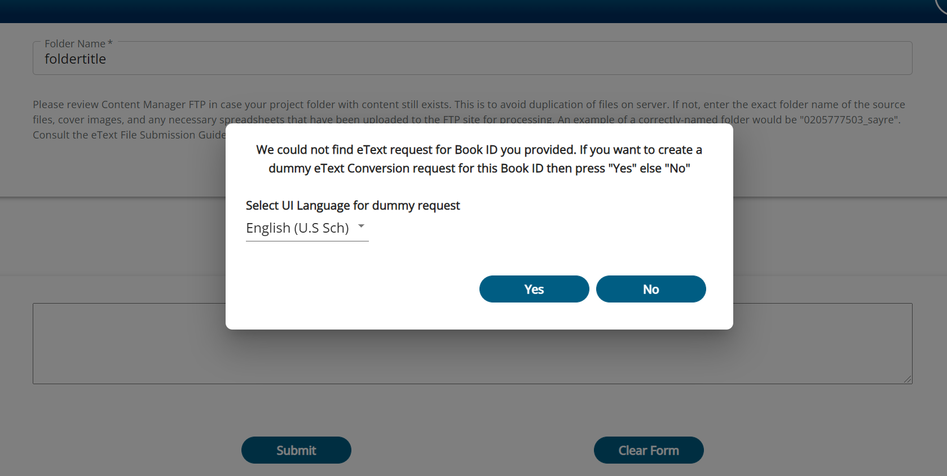

After clicking on “YES” , it will create a revision form. The success message will be appeared as follows-

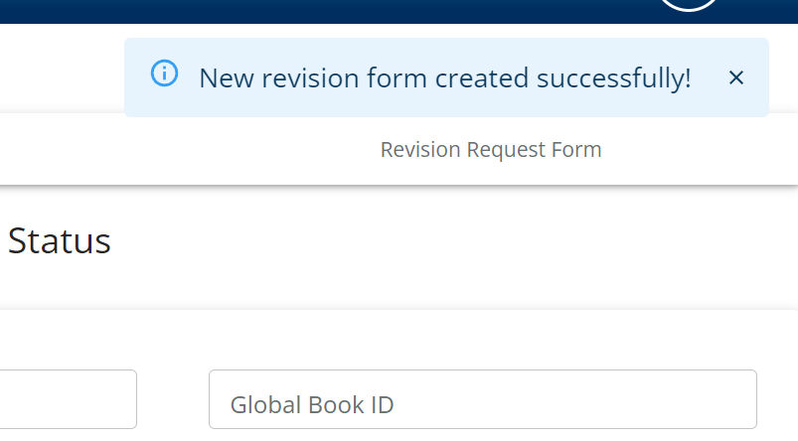

* After submitting revision/request form, we can click on any request/revision id from request queue and update/delete the data if required.